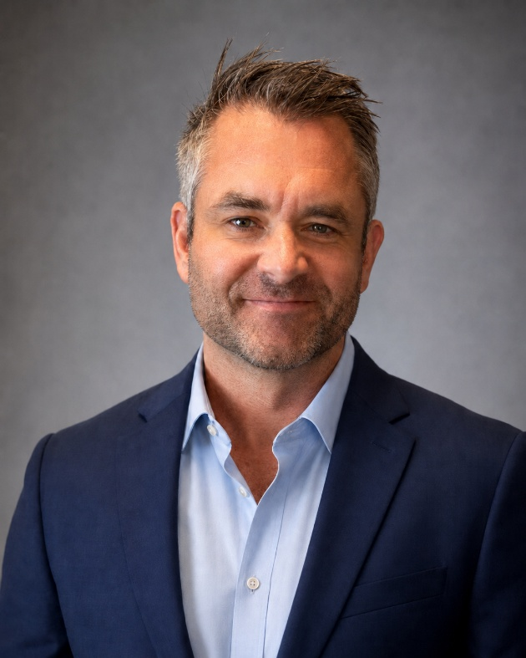
Lieutenant Colonel (LCol) Nick Verreault, Head, Joint Uncrewed Systems (UxS) Office
LCol Nick Verreault—an Ottawa native, aerospace engineer, and Royal Military College (RMC)-trained mechanical engineering graduate—has spent more than two decades at the forefront of Canada’s most demanding operational and technological missions. Since joining the Canadian Armed Forces (CAF) in 2002, he has been employed on multiple deployed operations and devoted 15 years to Canadian Special Operations Forces Command (CANSOFCOM), serving across a wide arc of influence: as a Force Development project officer, troop commander, Operations Officer, and ultimately as the director of special requirements Uncrewed Aerial Systems (UAS) and Counter UAS (C-UAS).
Today, as Head of the Joint Uncrewed Systems Office, he leads the CAF’s enterprise, driving transformation in joint uncrewed systems domains of air, ground, surface and underwater (Uncrewed Aerial Systems UAS, Uncrewed Ground Vehicles UGV, Uncrewed Surface Vehicles USV, Uncrewed Underwater Vehicles (UUV). A career built at the junction of engineering precision and Special Operations Forces (SOF) urgency, focused on unconventional problem solving and the relentless delivery of leading edge capabilities for the CAF.

